**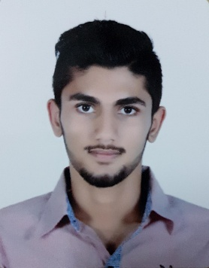******

**Skills:**

**Languages:** Arabic (Native), English (Excellent).

**Computer Skills**:

- Proficiency in all areas of Microsoft Office, including Access, Excel, Word and PowerPoint.

**Communication Skills:**

- Ability to work within a team or separate.

- Argument skills that convince the other.

- Neat, sociable, punctual and accurate

- Ability to communicate and contact with others.

**Work Skills:**

- Fast learning and easy to develop experience.

- Ability to work under pressure.

- Multitasking.

**Objectives:**

- I am seeking employment where I can use my talents and skills to grow and expand the company.

- I want to succeed in a stimulating and challenging environment, building the success of the company while I experience advancement opportunities.

- I want to excel in this field with hard work, perseverance and dedication.

- I am seeking a company where I can use my experience and education to help the company meet and surpass its goals.

- (April 2018): Worked as Advertising Space Sale in (Bin Falah Advertising).

Duties:

* Selling advertising spaces on digital signage network.
* Closing screen hosting deals.

- (July 2015): Worked as assistance in Adhari Park through community service program.

- Worked as a steward in most of races in Bahrain Road Runners (BRR).

Murtadha Hani Makki Ali Hassan

Single

March 23, 1998

Bahraini

**Contact**

**Personal Info.**

+973 38482188

**Training & Work Experiences:**

m-998-a

@hotmail.com



**Al-Naim secondary school, Manama, Bahrain**

**- (2013 - 2016):** Secondary Certificate in Science (Maths & Phycs)

**- Percentage:** 95.9%

**British Language Centre, Bahrain**

- Completed US A1C level

**University of Bahrain**

**- (2016 - Present):** Mechanical Engineering

**-** Percentage: 3.76/4

*Expected Graduation: July 2020*

**Autodesk Certified Professional**

- Professional excellence in Autodesk Inventor

**References:**

Mr. Mohammed Bin Falah

CEO @ Bin Falah Advertising

Mob: +973 66665543

*More references will be provided upon request.

**Education:**

- All sports especially: gymnastics and football

- Mathematics

- Drawing and designing

**Interests & Hobbies:**